Application form for academic volunteering candidates

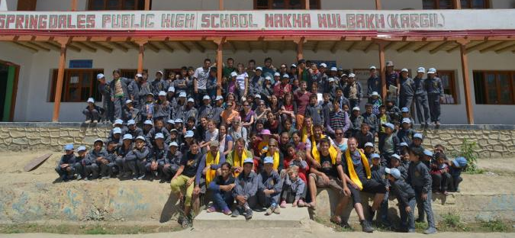
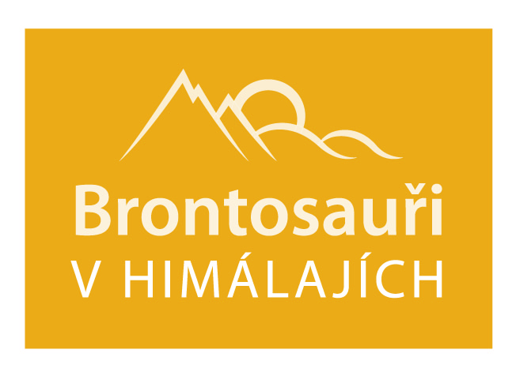
- Personal data
Name and surname: | Click here to insert text. | Photo:
Address: | Click here to insert text.
E-mail: | Click here to insert text.
Telephone: | Click here to insert text.
- Motivation
Describe your motivation. Why you want to become the volunteer with the Brontosauři v Himálajích organization. The description should range approximately from from 1000 up to 2000 characters including spaces.
- Length and estimated time of your stay
Write what are your options or what is your idea regarding the time of your stay. We would like to know how long your stay could be and during which season of the year. The answers could be: I am free for 2 months from March; I can help in Mulbekh for 5 weeks anytime during the year; I can teach there the whole school year; I do not know yeat, I have absolutely unlimited time possibilities and I would like to discuss it with you.
The answer can be very short or you can describe your time possibilities in more detail.
- Subject of my volunteering
Write your vision for you volunteer acting. You can either write just "Teaching children from primary school" or you can expand on your own vision how you would like to help to school.
- My strong points that could be helpful during volunteering
Write here what are your strong points and abilities for the kind of volunteering you are applying for. After reading this response here we should be certain that you have appropriate experience regarding the type of work you are applying for as a volunteer. The answer can be: jI am an elementary school teacher, and therefore I am a suitable candidate for training of local teachers.
The description should range approximately from from 1000 up to 2000 characters including spaces.
- My English
Fill in the chart with your language skills. Use the scale of evaluation prepared by the European Commission http://europass.cedefop.europa.eu/cs/resources/european-language-levels-cefr. The scale consists of three levels:
- Basic user (sublevels A1 and A2);
- Independent user (sublevels B1 and B2);
- Proficient user (subevels C1 and C2).
The example how to fill in the chart is in the bottom/left corner of it..
Understanding |  |  |  | Speaking |  |  |  | Writing
Listening |  | Reading |  | Spoken interaction |  | Spoken production
A1 | Basic User
- Further facts that could support your application
What we are mainly interested in: Do you have experience with travelling (especially to third-world countries)? Have you ever assisted to Brontosauři v Himálajích (such as helping install a photo exhibition, are you Himalayan patron, etc.)? Are you a member of the Brontosauři v Himálajích club? Have you adopted a child from our school? Have you placed your application before, so your interest to become a volunteer is a long-term one? Do you have experience with developmental help from other projects? Are you applying on the basis of recommendation of another volunteer who participated on the project last year? Or anything else you feel should be stated here.
We can take this information into account, but it does not play a decisive role in accepting the volunteer.
- How did you learn about us

And that is all, thank you for filling up the form. Please send it to us along with your CV, using the e-mail address below:
Dobrovolnictvi@BrontosaurivHimalajich.cz
Your application and your CV shall be assessed and we will contact you. We are pleased that you are interested in becoming a volunteer of the organization Brontosauři v Himálajích.

